**CN LAB 8 REPORT**

**OBJECTIVE :-**

Creating a Network Topology for RIP / RIPv2 in Packet Tracer.

**STEPS TAKEN**:

**STEP 1:**

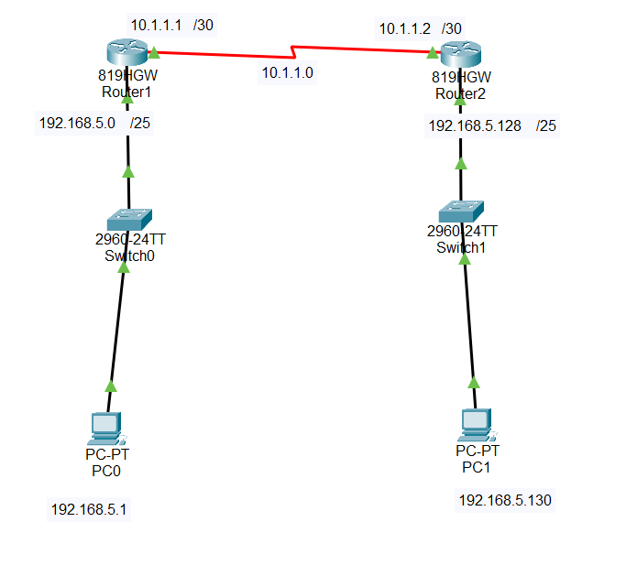

* Link the two routers with a Serial DCE-DTE cable.
* Connect the GigabitEthernet ports of R1 and R2 Routers to the Switch (SW0/SW1) ports with a straight-through cable.
* Connect PC0 to SW1, PC2 to SW2 with a straight cable.

**STEP 2:**

After typing the below commands on the Router, the connection is successful indicated by the green triangles on the cables below.

Click on the R1 Router you made in the setup, and open the settings. After that, go to the CLI tab. Use the commands below to give IP addresses to R1’s GigabitEthernet and Serial ports.

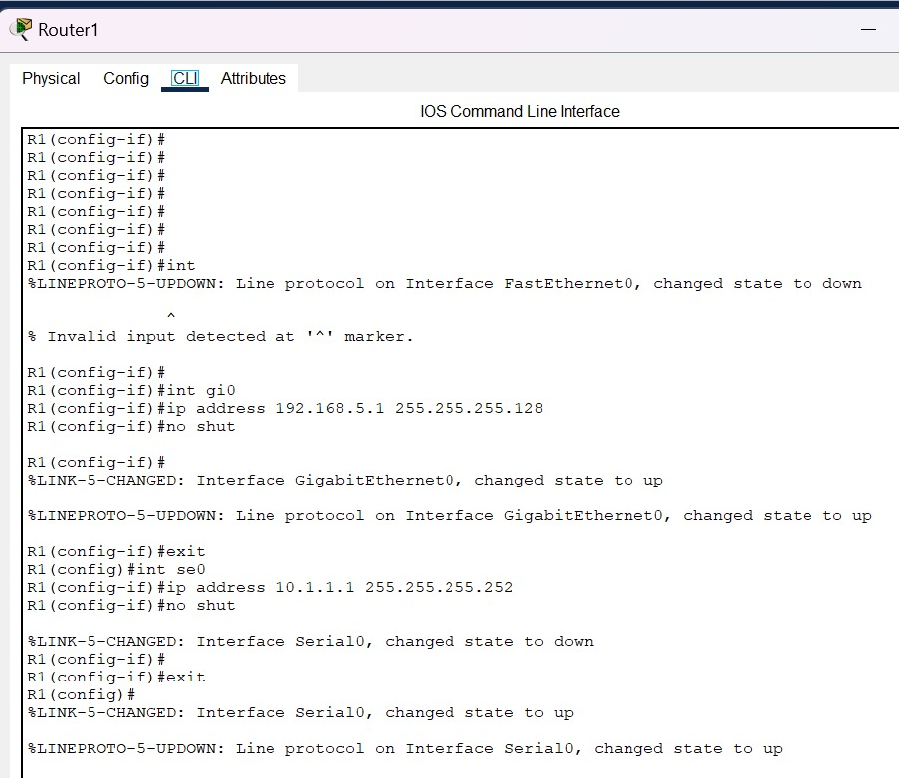

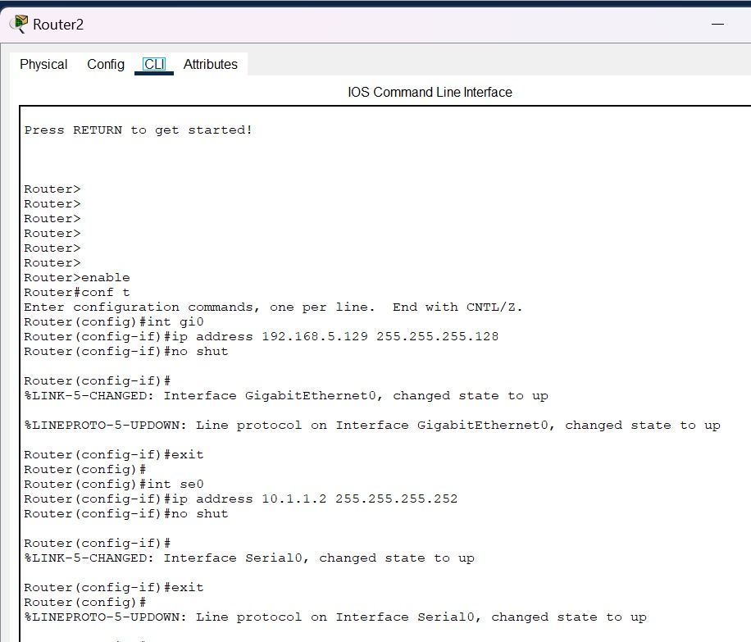

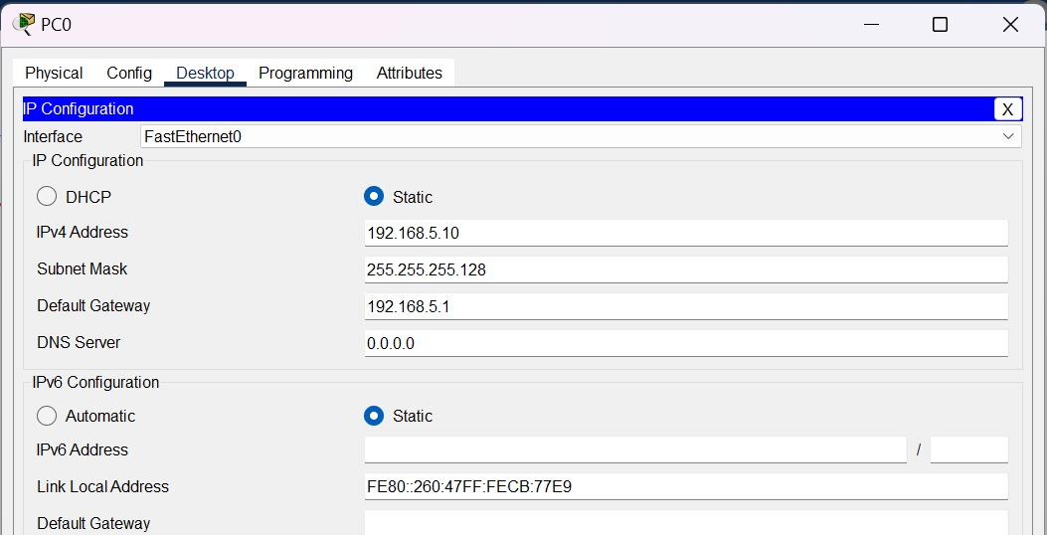

**STEP 3:**

Setting up RIP Protocol

Enabling RIP Configuration

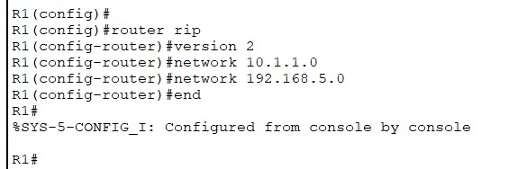

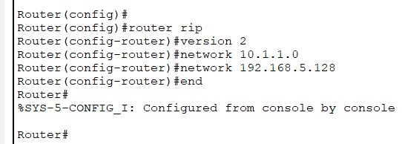

**STEP 4:**

Pinging to check the connectivity

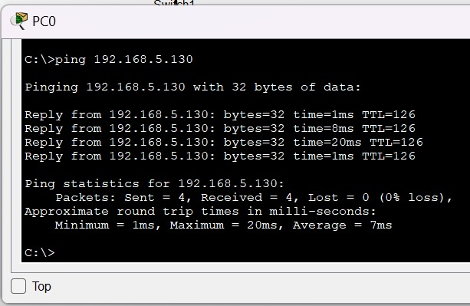

**STEP 5:**

execute the show ip route command to check the tables created on the routers and check the Routes.

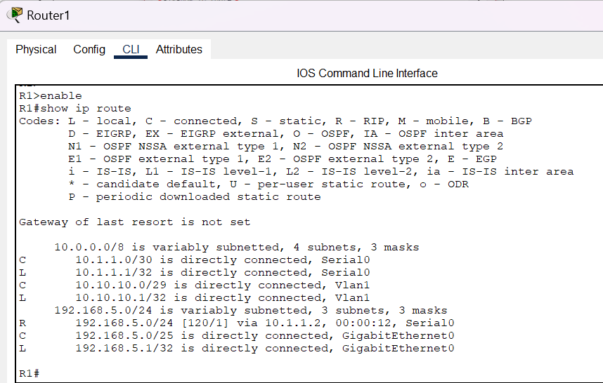



**STEP 6:**

You can see how routing updates are performed by applying the debug ip rip command to verify the routing protocol on Cisco Routers. As shown in the image below, you can see that RIP V2 is updating with 224.0.0.9 Multicast address.

